Self Driving Cars

Neural Network

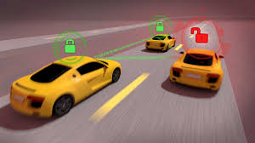

Presented By
Benjamin Hinchman
Jesse Gibbons
Kyle Tolliver
Richard Kung
Shane Mecham

Analysis Overview

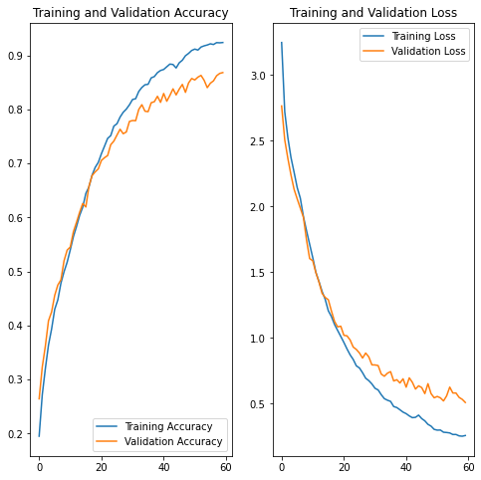

In general using the inception v3, made the training process fairly straightforward. We just needed to add a dense layer and an output layer. With these minor modifications we were able to get an accuracy of 90%, and if some hurdles hadn't presented themselves during the training phase of the model we would have continued working on the accuracy to get it higher. A 90% success rate doesn't seem very good when you consider that 10% of the time a one ton car is misidentifying road signs.

Conclusions and Caveats

We were able to train our neural networks to improve the accuracy. We also were able to run our algorithm on a CPU, TPU and GPU. We found the speed differences and performance differences on the different processing units.

https://colab.research.google.com/drive/1qqZMo0lBwkZ-1bFcb5B1FjVP80y0DZ-H?usp=sharing

